David Allen

G00375372

Week 3

**Contains**: project ideas brainstorming session, the project selected and a separate PowerPoint for the project inception deck.

**Team Blade Runner**:

**Scrum Master** - Ion Cirnini G00374920

**Product Owner** – Luke Byrne G00373744

**Software Engineer** – David Allen G00375372

**Software Engineer** – Sam Brownless G00260547

**Product Tester** – Ammad Aslam G00365389

Blade Runner

Project Management

## Brainstorming

Picture from project ideas brainstorming session:

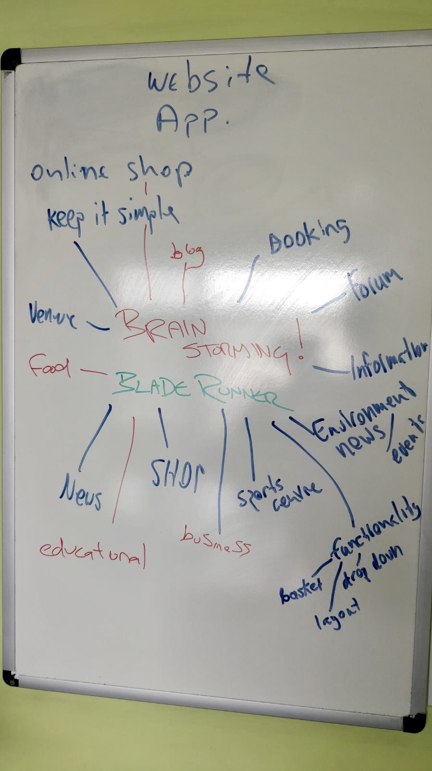

## Project Selection

This early stage in the initialisation phase of the project we had to kickstart the development team to get on top of the planning of project “Blade Runner”. We organised a meeting so we could strategize for the upcoming challenge of developing our product.

We had a quick brainstorming session and came up with multiple ideas, but overall agreed that the creation of a website was the direction we wanted to go. The main reason for us making this decision was for compatibility, if we were to design a website it would be not exclusive to mobile users like an app would.

Member main website themes/ideas:

David – venue – food/live music

Ion – restaurant/food

Luke – information/advertising

Ammad – restaurant menu

Sam – big screen sports

With collaboration in mind, we decided no idea was a bad idea and incorporated all members concepts. The final choice was a website for a Family friendly gastro pub / sports bar. The goal of this website will be to create awareness and exposure for the aforementioned pub/sports bar/restaurant. The website will also incorporate a feature for the end user to be added to a mailing list perhaps with the potential allow bookings and reservations to be made more easily for both staff and the end user.

Due to the somewhat limited time frame for the project some ideas had to be disregarded due to lack of practicality. We also had to be aware of our restrictions when designing the website taking into account factors such as budget, access to software, website compatibility and accessibility for consumers.

# Inception Deck

Project Inception Deck is on a PowerPoint attached with this document.

# References

The Agile Warrior. (2020). The Agile Inception Deck. [online] Available at: https://agilewarrior.wordpress.com/2010/11/06/the-agile-inception-deck/ [Accessed 12 Jan. 2020].